**Big Data Analysis Spring 2022**

**Question # 1**

* **Code**

import java.io.IOException;

import java.util.StringTokenizer;

import org.apache.hadoop.conf.Configuration;

import org.apache.hadoop.fs.Path;

import org.apache.hadoop.io.IntWritable;

import org.apache.hadoop.io.Text;

import org.apache.hadoop.mapreduce.Job;

import org.apache.hadoop.mapreduce.Mapper;

import org.apache.hadoop.mapreduce.Reducer;

import org.apache.hadoop.mapreduce.lib.input.FileInputFormat;

import org.apache.hadoop.mapreduce.lib.output.FileOutputFormat;

public class WordCount {

public static class TokenizerMapper

extends Mapper<Object, Text, Text, IntWritable>{

private final static IntWritable one = new IntWritable(1);

private Text word = new Text();

public void map(Object key, Text value, Context context

) throws IOException, InterruptedException {

StringTokenizer itr = new StringTokenizer(value.toString());

while (itr.hasMoreTokens()) {

word.set(itr.nextToken());

context.write(word, one);

}

}

}

public static class IntSumReducer

extends Reducer<Text,IntWritable,Text,IntWritable> {

private IntWritable result = new IntWritable();

public void reduce(Text key, Iterable<IntWritable> values,

Context context

) throws IOException, InterruptedException {

int sum = 0;

for (IntWritable val : values) {

sum += val.get();

}

result.set(sum);

context.write(key, result);

}

}

public static void main(String[] args) throws Exception {

Configuration conf = new Configuration();

Job job = Job.getInstance(conf, "word count");

job.setJarByClass(WordCount.class);

job.setMapperClass(TokenizerMapper.class);

job.setCombinerClass(IntSumReducer.class);

job.setReducerClass(IntSumReducer.class);

job.setOutputKeyClass(Text.class);

job.setOutputValueClass(IntWritable.class);

FileInputFormat.addInputPath(job, new Path(args[0]));

FileOutputFormat.setOutputPath(job, new Path(args[1]));

System.exit(job.waitForCompletion(true) ? 0 : 1);

}

}

* 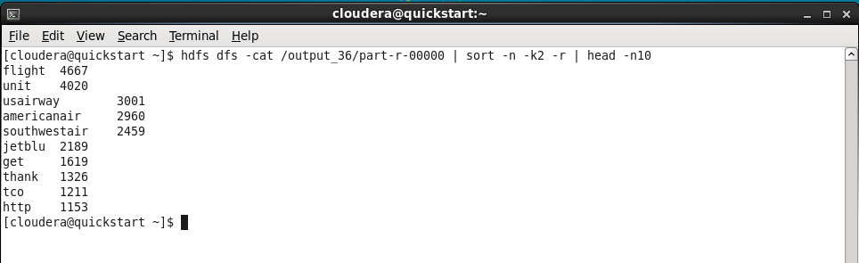**Output**

**Question # 2**

* **Part A**

import java.awt.List;

import java.io.IOException;

import java.util.*;

import java.io.IOException;

import org.apache.hadoop.fs.Path;

import org.apache.hadoop.conf.*;

import org.apache.hadoop.io.*;

import org.apache.hadoop.mapreduce.*;

import org.apache.hadoop.mapreduce.lib.input.FileInputFormat;

import org.apache.hadoop.mapreduce.lib.input.TextInputFormat;

import org.apache.hadoop.mapreduce.lib.output.FileOutputFormat;

import org.apache.hadoop.mapreduce.lib.output.TextOutputFormat;

public class WordCount {

public static class Map extends Mapper<LongWritable, Text, Text, FloatWritable> {

private Text result = new Text();

private FloatWritable counter = new FloatWritable();

public void map(LongWritable key, Text value, Context context)

throws IOException, InterruptedException {

String lineParser = value.toString();

String strArr[] = lineParser.split(",");

if (strArr.length >= 3) {

if(!strArr[1].equalsIgnoreCase("Males")) {

result.set("Total Males Literate");

int count = Integer.parseInt(strArr[1]);

float percentage = Float.parseFloat(strArr[3]);

percentage = (float) (percentage /100.0);

float total = percentage * (float)count;

counter.set(total);

context.write(result, counter);

result.set("Total Females Literate");

count = Integer.parseInt(strArr[2]);

percentage = Float.parseFloat(strArr[4]);

percentage = (float) (j/100.0);

total = percentage * (float) count;

counter.set(k);

context.write(result, counter);

}

}

}

}

public static class Reduce extends Reducer<Text, FloatWritable, Text, FloatWritable> {

public void reduce(Text key, Iterable<FloatWritable> values,

Context context) throws IOException, InterruptedException {

float sum = 0;

for (FloatWritable val : values) {

sum += val.get();

}

context.write(key, new FloatWritable(sum));

}

}

public static void main(String[] args) throws Exception {

Configuration conf = new Configuration();

Job job = Job.getInstance(conf, "word count");

job.setJarByClass(WordCount.class);

job.setMapOutputKeyClass(Text.class);

job.setMapOutputValueClass(FloatWritable.class);

job.setOutputKeyClass(Text.class);

job.setOutputValueClass(FloatWritable.class);

job.setMapperClass(Map.class);

job.setReducerClass(Reduce.class);

job.setInputFormatClass(TextInputFormat.class);

job.setOutputFormatClass(TextOutputFormat.class);

FileInputFormat.addInputPath(job, new Path(args[0]));

FileOutputFormat.setOutputPath(job, new Path(args[1]));

job.waitForCompletion(true);

}

}

* **Output**

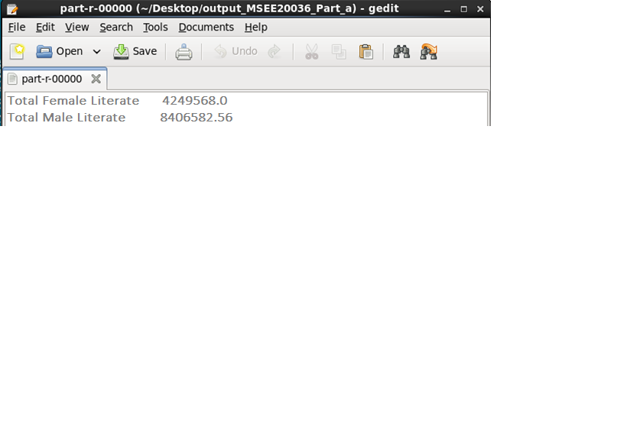

* **Part B**

import java.awt.List;

import java.io.IOException;

import java.util.*;

import java.io.IOException;

import org.apache.hadoop.fs.Path;

import org.apache.hadoop.conf.*;

import org.apache.hadoop.io.*;

import org.apache.hadoop.mapreduce.*;

import org.apache.hadoop.mapreduce.lib.input.FileInputFormat;

import org.apache.hadoop.mapreduce.lib.input.TextInputFormat;

import org.apache.hadoop.mapreduce.lib.output.FileOutputFormat;

import org.apache.hadoop.mapreduce.lib.output.TextOutputFormat;

public class WordCount {

public static class Map extends Mapper<LongWritable, Text, Text, FloatWritable> {

private Text result = new Text();

private FloatWritable counter = new FloatWritable();

public void map(LongWritable key, Text value, Context context)

throws IOException, InterruptedException {

String lineParser = value.toString();

String strArr[] = lineParser.split(",");

if (strArr.length >= 3) {

if(!strArr[1].equalsIgnoreCase("Males")) {

result.set("Literate Males");

float percentage = Float.parseFloat(strArr[3]);

counter.set(percentage);

context.write(result, counter);

result.set("Literate Females");

percentage = Float.parseFloat(strArr[4]);

counter.set(percentage);

context.write(result, counter);

}

}

}

}

public static class Reduce extends Reducer<Text, FloatWritable, Text, FloatWritable> {

// overriding reduce method(runs each time for every key )

public void reduce(Text key, Iterable<FloatWritable> values,

Context context) throws IOException, InterruptedException {

float sum = 0;

int avgCounter = 0;

float avg = 0.0

for (FloatWritable val : values) {

avgCounter += 1;

sum += val.get();

}

avg =(float)sum/avgCounter;

context.write(key, new FloatWritable(avg));

}

}

public static void main(String[] args) throws Exception {

Configuration conf = new Configuration();

Job job = Job.getInstance(conf, "word count");

job.setJarByClass(WordCount.class);

job.setMapOutputKeyClass(Text.class);

job.setMapOutputValueClass(FloatWritable.class);

job.setOutputKeyClass(Text.class);

job.setOutputValueClass(FloatWritable.class);

job.setMapperClass(Map.class);

job.setReducerClass(Reduce.class);

job.setInputFormatClass(TextInputFormat.class);

job.setOutputFormatClass(TextOutputFormat.class);

FileInputFormat.addInputPath(job, new Path(args[0]));

FileOutputFormat.setOutputPath(job, new Path(args[1]));

job.waitForCompletion(true);

}

}

* **Output**

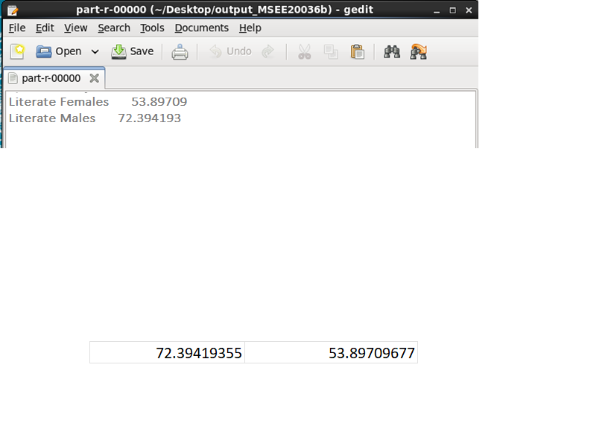

* **Part C**

import java.awt.List;

import java.io.IOException;

import java.util.*;

import java.io.IOException;

import org.apache.hadoop.fs.Path;

import org.apache.hadoop.conf.*;

import org.apache.hadoop.io.*;

import org.apache.hadoop.mapreduce.*;

import org.apache.hadoop.mapreduce.lib.input.FileInputFormat;

import org.apache.hadoop.mapreduce.lib.input.TextInputFormat;

import org.apache.hadoop.mapreduce.lib.output.FileOutputFormat;

import org.apache.hadoop.mapreduce.lib.output.TextOutputFormat;

public class WordCount {

public static class Map extends Mapper<LongWritable, Text, Text, FloatWritable> {

private Text result = new Text();

private FloatWritable counter = new FloatWritable();

public void map(LongWritable key, Text value, Context context)

throws IOException, InterruptedException {

String lineParser = value.toString();

String strArr[] = lineParser.split(",");

if (strArr.length >= 3) {

if(!strArr[1].equalsIgnoreCase("Males")) {

result.set("Total Literate");

int count1 = Integer.parseInt(strArr[1]);

float percentage1 = Float.parseFloat(strArr[3]);

int count2 = Integer.parseInt(strArr[2]);

float percentage2 = Float.parseFloat(strArr[4]);

percentage1 = (float) (percentage1/100.0);

percentage2 = (float) (percentage2/100.0);

float total = (percentage1 * (float)count1) + (percentage2 * (float)count2);

counter.set(total);

context.write(result, counter);

result.set("Total Iliterate");

int count1 = Integer.parseInt(strArr[1]);

float percentage1 = Float.parseFloat(strArr[3]);

int count2 = Integer.parseInt(strArr[2]);

float percentage2 = Float.parseFloat(strArr[4]);

percentage1 = 1- (float) (percentage1/100.0);

percentage2 = 1 - (float) (percentage2/100.0);

float total = (percentage1 * (float)count1) + (percentage2 * (float)count2);

counter.set(total);

context.write(result, counter);

}

}

}

}

public static class Reduce extends Reducer<Text, FloatWritable, Text, FloatWritable> {

// overriding reduce method(runs each time for every key )

public void reduce(Text key, Iterable<FloatWritable> values,

Context context) throws IOException, InterruptedException {

float sum = 0;

for (FloatWritable val : values) {

sum += val.get();

}

context.write(key, new FloatWritable(sum));

}

}

public static void main(String[] args) throws Exception {

Configuration conf = new Configuration();

Job job = Job.getInstance(conf, "word count");

job.setJarByClass(WordCount.class);

job.setMapOutputKeyClass(Text.class);

job.setMapOutputValueClass(FloatWritable.class);

job.setOutputKeyClass(Text.class);

job.setOutputValueClass(FloatWritable.class);

job.setMapperClass(Map.class);

job.setReducerClass(Reduce.class);

job.setInputFormatClass(TextInputFormat.class);

job.setOutputFormatClass(TextOutputFormat.class);

FileInputFormat.addInputPath(job, new Path(args[0]));

FileOutputFormat.setOutputPath(job, new Path(args[1]));

job.waitForCompletion(true);

}

}

* **Output**

